**Ejercicio 3**

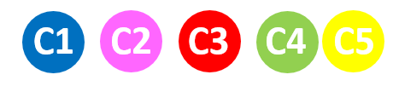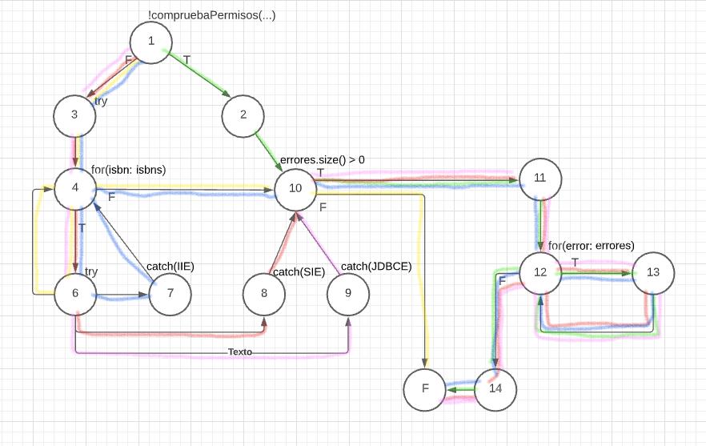

Cc= 20-14+2=8

|  |  |  |  |  |  |  |
| --- | --- | --- | --- | --- | --- | --- |
| Casos de prueba | Datos de entrada | | | | | Resultado esperado |
| **Login** | **Contraseña** | **Socio** | **ISBN** | **Conexión BD** |
| C1 | admin | 123456 | Alberto | [HOLAS] | True | “ISBN invalido: HOLAS” |
| C2 | admin | 123456 | Alberto | [12345] | False | “CONEXIÓN invalida” |
| C3 | admin | 123456 | Fran | [12345] | True | “SOCIO invalido” |
| C4 | cliente | 123456 | Alberto | [12345] | True | “Error permisos” |
| C5 | admin | 123456 | Alberto | [12345] | True | - |